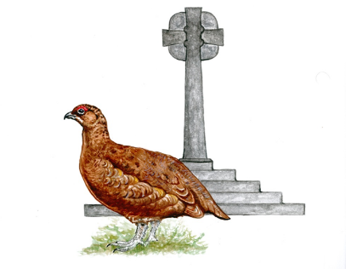
Stanhope Barrington C of E
Westcroft
Stanhope
Bishop Auckland
Co Durham
DL13 2NU
Tel: 01388 528218
Email: admin@stanhopebarrington.org.uk
Website: https://www.stanhopebarrington.org.uk/

Primary School

Head Teacher: Mrs D Cross

School Number 840 3087

Dear Diamond Parents/Carers 5th November 2025

Re: Diamond Class Assembly

You may remember that one of our AFI’s (Area For Improvement) following our SIAMS Church Inspection last year was for us to give our children to opportunity to develop and deliver their own assemblies.

As such, every Learning Zone will be putting together their own assembly and delivering it to the whole school along with parents/carers of children in that Learning Zone. There will be one Learning Zone assembly per half term.

This half term it is the turn of the Diamond Learning Zone who will be delivering their assembly on Thursday 13th November 2025 at 9.10 till 9.30am.

You are therefore invited to attend your child’s assembly (Diamond Parents/Carers only) and we would love to see you there if possible.

The theme and content of the assembly is about National Anti-bullying week.

Yours sincerely
Mrs D Cross

Mrs D Cross
Head Teacher

